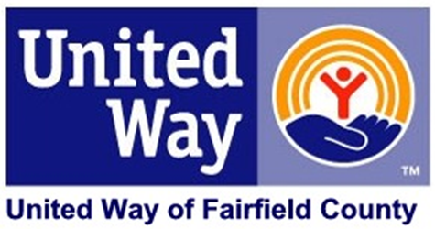

Dear Fellow Employee:

After a terrific effort, our United Way campaign has come to an end. I want to personally thank you for believing in our community by your investment in Fairfield County. Your support exemplifies the spirit of the United Way movement, **LIVE UNITED.** Your donation is helping to advance the common good by giving your time, talents and treasure. You should feel proud in knowing that you have made a measurable difference in so many lives. Because you cared enough to give, thousands of families – including some in your neighborhood – will receive the help they need to improve their lives.

As a member of the [COMPANY NAME] team, you have focused on the community and demonstrated through your investment that we are willing to step up and become involved in helping to build a stronger, more caring Fairfield County.

This year, we, here at [COMPANY NAME] we raised more than [$ AMOUNT] for United Way – a [AMOUNT %] increase over last year! The investment we all made will make a real difference in the issues and problems that impact our community every day.

Thank you so much for joining us to LIVE UNITED. Because of you, United Way is able to help people, support families, and strengthen communities.

Sincerely,

CEO