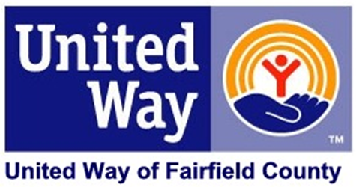

Dear________:

Tomorrow is the final day of the [COMPANY NAME] campaign for United Way of Fairfield County. Already [PARTICIPATION RATE %] of your colleagues have participated, we have reached [GOAL PERCENTAGE %] of our initial goal. We have raised [DOLLARS PLEDGED] for our community thus far!

That represents a fantastic commitment to improving lives throughout our community. I am so grateful to you all.

With that being said, I know that we have an opportunity in this last push to do something special. Every additional person that chooses to **LIVE UNITED** and every additional dollar that is donated helps address critical needs in our community. Will you help?

If you have not already given, please consider making a pledge and investing in better Education, Financial Stability, and Health throughout our region. Your gift can make long-lasting improvements in the lives of hardworking individuals’ right here in our community.

Any questions about United Way or about making your gift, please do not hesitate to contact me.

Thank you for all that you do to **LIVE UNITED!**

Sincerely,

CEO