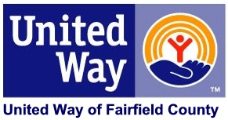

Today is the midpoint of the [COMPANY NAME] campaign for United Way of Fairfield County, and we are off to a great start! Your colleagues are making their commitments to achieve the biggest possible improvements in the lives of people throughout Fairfield County.

**If you have already given, THANK YOU!** Because you have taken the pledge to LIVE UNITED, you are creating a brighter future for our community.

I**f you have not pledge your gift, please consider donating.** Your donation can help Fairfield County address critical needs in our community. A gift to United Way of Fairfield County helps achieve bold goals in the areas of Education, Financial Stability, and Health.

* **Education** – Increasing kindergarten readiness, positive familial engagement, decreasing risk factors in the youth community and increasing high school graduation rates and success.
* **Financial Stability** – Ensuring that individuals and families achieve financial stability, creating a safety net of services so that people in crisis have access to emergency food and shelter, and making sure our community is prepared to respond to disasters and emergencies.
* **Health** – Providing support services that increase the ability of the elderly and individuals with disabilities to complete independent activities of daily living, and ensuring that people who seek care, get care, and maintain healthy nutrition and physical fitness.

If you have any questions about United Way, or about making your gift, please do not hesitate to contact me.

Thank you for considering how you and your family can **LIVE UNITED!**

***Please remember that United Way pledges are due by [MONTH XX].***

Sincerely,

Company Campaign Chair