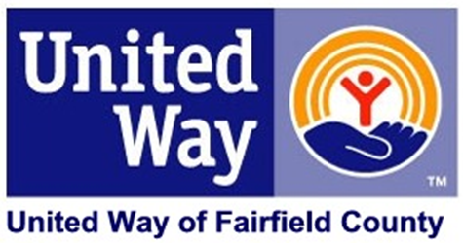

Dear _______:

The [COMPANY NAME] United Way campaign **starts next week!** This is a great opportunity for us to have a little bit of fun as we learn about the conditions in our community. You will see how United Way is focused on creating a better future for people throughout our region.

Please join us in as many of the events and activities as you can:

* Learn about the impact your United Way contributions make in our community.
* Participate in a volunteer project.
* Take part in one of the fun team-building activities.

Of course, we will also give you the opportunity to **LIVE UNITED** and support the United Way of Fairfield County when you: Give. Advocate. Volunteer.

Here’s a thought before our campaign kickoff: Ten years from today, someone who is currently 4 years old will be starting 9th grade. If you could do anything to improve the community for that child – and all of us – by the year [YYYY (TEN YEARS FROM NOW)], what would you do?

Look for more information coming next week!

Sincerely,

CEO