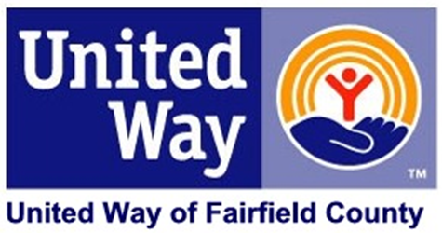

Dear ________:

Mark your calendar! I am personally inviting you to an exciting event that you will not want to miss.

On [DATE] at [TIME], our annual United Way Campaign will kick-off with [DESCRIPTION OF SOME ACTIVITIES]. Last year we raised [AMOUNT], and we believe we can do even better in [NEXT YEAR].

The United Way movement is to **LIVE UNITED. Give. Advocate. Volunteer.** Our employees have and will continue to follow those precepts by doing good work for our community. Our continued commitment to United Way makes a difference in the lives of thousands of families’ right here at home. The funds we raised last year were put to work to help men, women and children right here in Fairfield County. Through United Way’s leadership – focusing on excellence and accountability – you can have confidence that your donations directly impact our community by influencing the condition of all.

Join me to **LIVE UNITED** by helping your community to advance the common good through the efforts of United Way of Fairfield County. Come learn how you can be a part of this positive change. See you on [KICKOFF DATE]!

Sincerely,

CEO